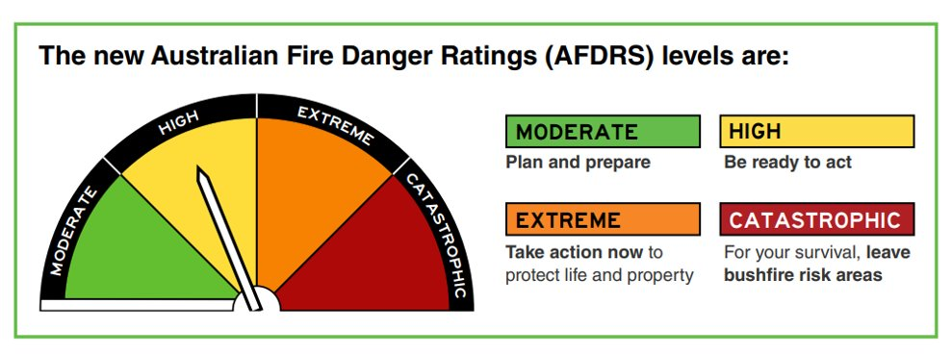
Beaconsfield Upper Primary School
School Procedures for the Bushfire Season
In all fire conditions families are encouraged to enact their own fireplans.
This plan informs families and the local community of what will happen under different conditions during the bushfire season in order to keep our students and staff safe.
Forecast Fire Danger Rating/ local bushfire conditions | Action | Communication
Catastrophic | - SCHOOL CLOSED  - Out of hours care cancelled  - No staff onsite | - Parents contacted directly, up to 3 days prior, confirmed the day before via Sentral or SMS  - Decision will not change  - Local CFA notified
Extreme | - RELOCATION PLAN ENACTED  - Out of hours care cancelled  - No staff onsite | - Parents contacted directly as soon as possible.  - Decision will not change  - Local CFA notified
High | - Families enact their bushfire survival plan  - School remains open  - Monitor Vic Emergency website/ ABC radio/ keep in contact with Regional Emergency Management  - Follow advice of Emergency services | - Parents notified of any changes to situation  - Parents need to make sure we can contact them easily or let us know who the best contact is for that day.
If fire starts spontaneously during the day and may possibly impact the school. | - Monitor Vic Emergency website/ ABC radio/ keep in contact with Regional Emergency Management  - Contact emergency services  - Follow advice of Emergency Services  - If time allows and if safe to do so, evacuate with Emergency services escort  - Shelter in place in classroom building. | - Parents notified of any changes to situation if possible  - Parents need to make sure we can contact them easily or let us know who the best contact is for that day.  - Please note: If parents arrive during this time they will be strongly advised to stay with us.

Dear Parents,
Beaconsfield Upper Primary is registered as a Bush Fire at Risk school category 2. As such we have been told to close on Catastrophic days. As per our school procedures sheet attached, notification of a Catastrophic day will be given as soon as possible and will be confirmed the day prior via Sentral and notes home.
If you haven’t already, we strongly advise you to obtain the Sentral App. Please ensure that your contact details are up to date as in an emergency we will be issuing a SMS to our families.
On EXTREME fire days we will be relocating to the Berwick Leisure Centre at Berwick Secondary College. On these days there will be no “Before and After School Care” available. It is important to note that it will be the parents’ responsibility to get the children to and from Berwick Leisure centre.
While the Leisure Centre is a safe environment, please note that we will be sharing the facility with Harkaway Primary School. Students will have a modified program for the day.
To assist with traffic control in the morning and afternoon, parents are advised to drop the students at the Berwick Football clubrooms, entering in through the gate and then travelling around the oval to exit. Once rolls are marked the students and staff will then walk across to the leisure centre for the day. At the end of the day we will reverse the process, walking the students back to the football clubrooms for departure at the end of the day. Staff will be in attendance from 8.30 am.
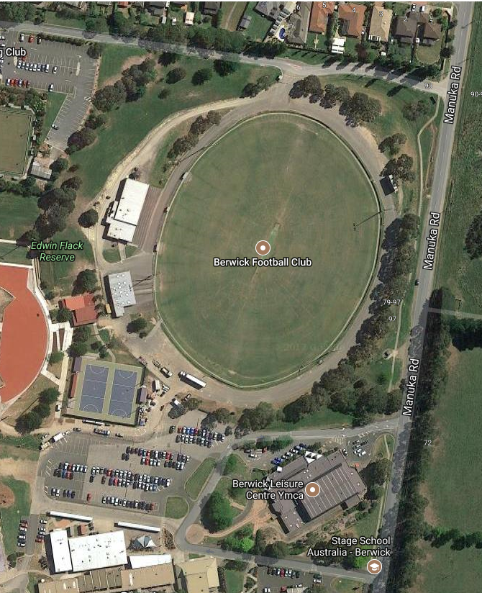
Leisure centre facility for relocation on EXTREME days
Area for student play and lunch time breaks. Staff will supervise.
Students to be dropped off and picked up at the Football Clubrooms
Enter and depart via football ground for student drop off and pick up

